CPE 301 Final Project

December 11, 2022

Mohammedali Afshar, Caleb Stickler

**Technical Constraints**: Works at 20 degrees Celsius or higher. Uses a 5 V power supply (with 9 volt jack). Stepper motor does not work (not enough power driven to it). Fan Motor does not work (unable to control when it starts and stops).

**Picture**

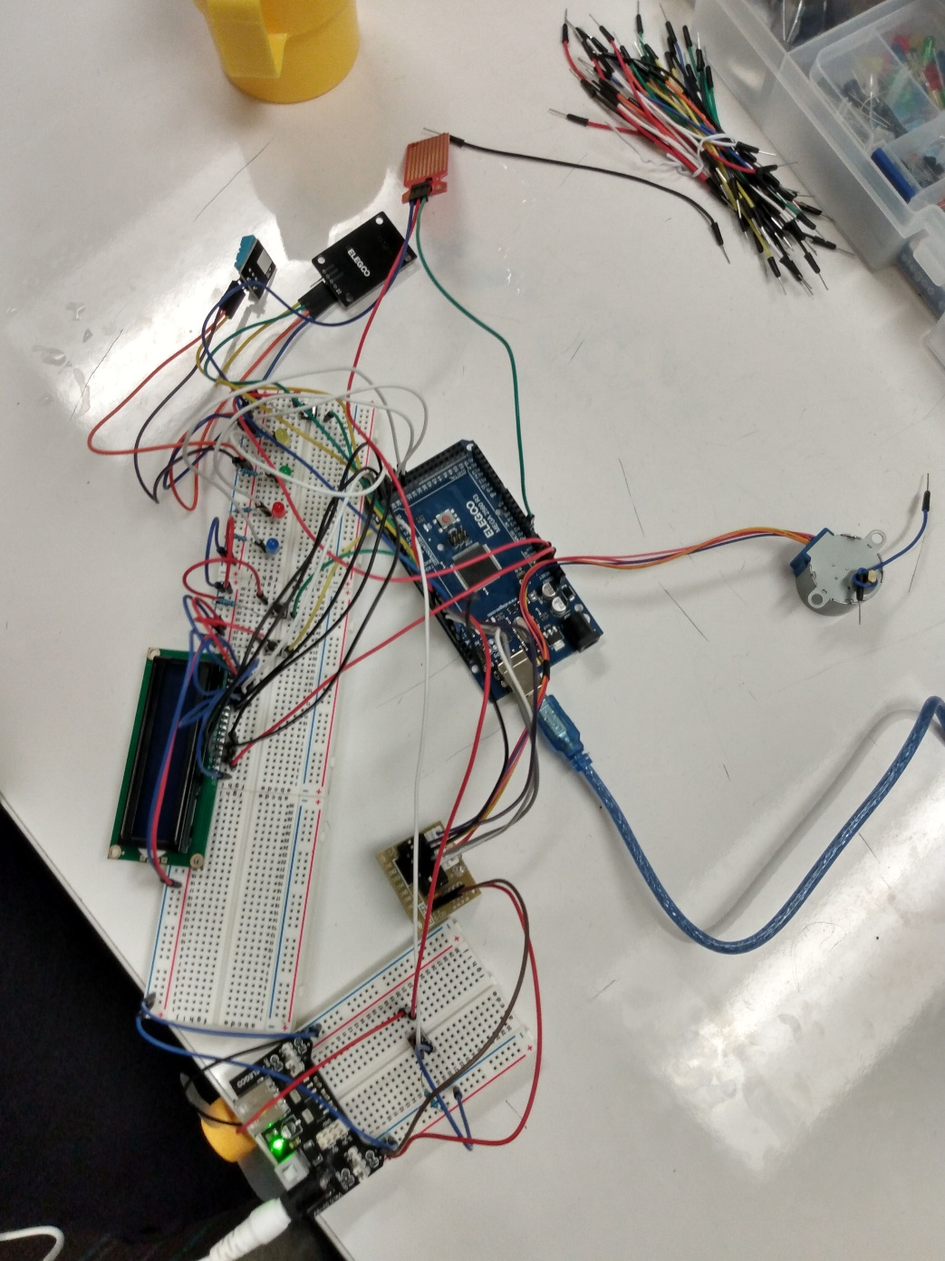

**Screenshots**

The following screenshots are of the Serial port showing the sensor readings and time-stamped state changes

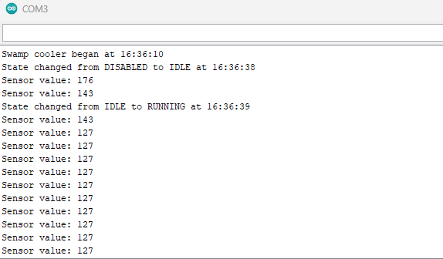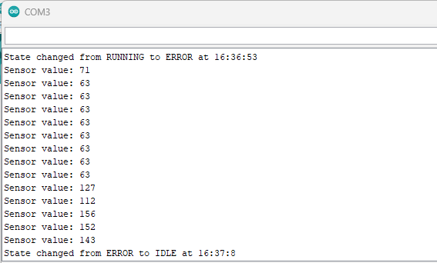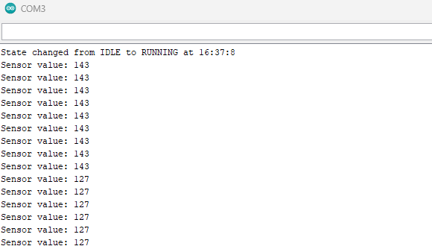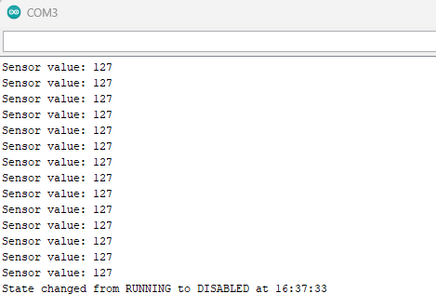

**Device Specification**

*DHT11 Temperature & Humidity Sensor*: <https://components101.com/sensors/dht11-temperature-sensor>

*DS1307-Module-V03 Real-Time Clock*: <https://arduinogetstarted.com/tutorials/arduino-ds1307-rtc-module>

*Water Sensor*: <https://curtocircuito.com.br/datasheet/sensor/nivel_de_agua_analogico.pdf>

*LCD1602 Module:* <https://create.arduino.cc/projecthub/najad/interfacing-lcd1602-with-arduino-764ec4>

*28BYJ-48 Stepper Motor with ULN2003 Driver*: <https://www.makerguides.com/28byj-48-stepper-motor-arduino-tutorial/>

*Fan Motor*: <https://create.arduino.cc/projecthub/ingo-lohs/first-test-super-starterkit-from-elegoo-motor-3-6v-dc-5b199d>

*External Power Module*: <https://components101.com/modules/5v-mb102-breadboard-power-supply-module>

**Video Link**: <https://clipchamp.com/watch/WHfkfWRdEbE>

**Schematic**

